**MOUNT KENYA UNIVERSITY**

**SCHOOL OF COMPUTING AND INFORMATICS**

**DEPARTMENT OF INFORMATION TECHNOLOGY**

**UNIT TITLE: COMPUTING PROJECTS DEVELOPMENT APPROACHES**

**UNIT CODE: CIT2106**

**PROJECT TITLE: TAMTAM HOTEL MANAGEMENT SYSTEM**

**BY: ERIC LABAN**

**REG: CIT/2019/57028**

**SUPERVISOR NAME: KELVIN NJAGI.**

**This project proposal submitted in partial fulfilment of requirement for the Mount Kenya University award of CERTIFICATE IN INFORMATION TECHNOLOGY**

# DECLARATION

I hereby declare that this is my original work of software research and discovery and actually there is no any other person and it has not been presented in any other institution

**SIGNATURE: ..........................................**

**STUDENT NAME:**

**ID NO:**

# SUPERVISOR

I the undersigned do hereby certify that this is a true report for the project undertaken by the above-named student under my supervision and that it has been submitted to Mount Kenya University with my approval

Signature……………………………………………………. Date……………………………

# DEDICATION

I dedicate this to my family and encouraging friend for their continued support throughout my research on this project, Secondly, my sincere thanks also go to my supervisor who sacrifice all his time and energy by giving me advice and great moral support by giving me guideline on how to write this project proposal. Last but not least, to myself for it might be the biggest achievement in my life time.

# ACKNOWLEDGEMENT

Success in life is never attained single handedly; it is on this note that I express my heartfelt gratitude to God for the strength and wisdom, and also various people who have assisted me in various ways to accomplish my project. My sincere appreciation goes to my supervisor for his useful and constructive guidance on this project. Finally, it will be my pressure to thank my classmates and guardian who have supported and encourage me throughout the writing of this proposal for they have provided valuable assistance and guidance.

# ABSTRACT

The purpose of this project is to improve several problems encountered in TAMTAM hotel management system like loss of records of details of the specific guest arrives at the hotel, loss of records of received goods from suppliers since everything are recorded manually and also control dishonesty of workers

# 

# TABLE OF CONTENT

Contents

DECLARATION ii

SUPERVISOR ii

DEDICATION iii

ACKNOWLEDGEMENT iv

ABSTRACT v

TABLE OF CONTENT vi

2 CHAPTER ONE 1

1.1 INTRODUCTION 1

1.2 BACKGROUND 2

1.3 PROBLEM STATEMENT 3

1.4 PROPOSED SOLUTION 3

1.5 0BJECTIVES 4

1.6 JUSTIFICATION 5

1.7 SCOPE 5

1.8 BUDGET 5

1.8 JUSTIFICATION 6

2.0 CHAPTER TWO 8

2.1 LITERATURE REVIEW 8

2.2 INTERNATIONAL CASE STUDY 8

2.3 VICTORIA CROWN PLAZA HOTEL 8

2.4 LOCAL CASE STUDY (Hilton Hotel management system) 11

2.5 PROPOSED SYSTEM 12

2.6 CONCLUSION 13

3.0 CHAPTER THREE 14

3.1 METHODOLOGY 14

3.2 System Design 15

3.3 Data Collection 15

3.4 Limitation of the study 15

3.5 SYSTEM DEVELOPMENT TOOLS AND TECHNIQUES. 16

3.6 Context Diagram 16

3.7 Data Flow Diagram 17

3.8 FLOWCHART 18

3.9 Entity Relation Diagram 19

4.0 CHAPTER FOUR 21

4.1 SYTEM ANALYSIS AND REQUIREMENTS MODELING 21

4.2 Description of The Current system 21

4.3 System Analysis and model 22

4.4 Requirements Definition 23

4.5 Functional Requirements 23

4.6 Non-functional requirements 23

5.0 CHAPTER FIVE 24

5.1 SYSTEM DESIGN 24

**5.0 Introduction** 24

5.2 Database Design 24

**5.3 Interface design** 29

5.4 Screenshots of the system designs. 30

6.0 CHAPTER SIX 36

6.1 SYSTEM IMPLEMENTATION AND TESTING 36

2.1 Introduction 36

2.2 Accessing the system 36

2.3 6.2 System installation 36

2.4 6.3 System Test plan 37

2.5 6.4 SYSTEM TESTING 37

3 Strategies used for testing 37

3.1 Unit Testing 37

3.2 Integration Testing 38

3.3 Acceptance Testing 38

3.4 System changeover 38

4 CHAPTER SEVEN 39

7.1 LIMITATIONS, CONCLUSIONS AND RECOMMENDATIONS 39

4.1 Introduction 39

4.2 Limitations 39

4.3 Achievements 39

4.4 Reduction of time wasting by acting as the connecting bridge between the buyer and the seller 40

4.5 7.2. Recommendation 40

4.5.1 System Support 40

4.5.2 System Support 40

4.5.3 User Training 40

4.5.4 Security 40

4.5.5 Security 40

4.6 Conclusion 40

4.7 REFERENCE 41

4.8 Some code for the system. 42

# CHAPTER ONE

## INTRODUCTION

The project explores the way of reducing challenges encountered in hotel management system. TAMTAM Hotel management system is intended to keep the records of all guest arrives at the hotel and room allotted to them and also generate the bills for each guest. It also keeps the record of food and various service availed by the customers. TAMTAM hotel management system intends to get a precise arrival and departure time of the guest by recoding day-to-day task like room allocation and also keeps the records of goods received from suppliers and details of each employee in every department. Finally, the existing system of TAMTAM hotel was very difficult because it is manual and consumes a lot of time. The purpose of the proposed system is to improve the service of the client.

## BACKGROUND

TAMTAM is a hotel situated in Machakos County, one kilometer from Machakos town. It provides accommodation, food and beverage and different types of services. It started in the year 2015 with 15 employees but currently has more than hundred and twenty employees. The Hotel management system is currently managed manually where the personnel use pen and paper for data record. They have been experiencing several problems as their records are done manually which is very tedious work.

## PROBLEM STATEMENT

I was able to conduct interview to the managers of the hotel and other workers in the hotel where I discovered the following problems.

First and foremost, the manager told me that keeping the records of the guest manually was very difficult and costly. These become tedious when finding the details of a specific person in the book. Calculating the bill of the guest manually using pen and paper was also very difficult since human being is prone to error it might cause disagreement between clients and the recipient if error is made.

Time wastage was another problem since the clients are attended manually especially at the front desk. I also interview the security department and discovered that most of the time customers complain that their things get lost and is difficult to recover.

Double booking of the room also another major problem since records are kept manually and it might be mistaken to book the same room for different customers. Finally keeping the records of goods received from suppliers manually was very risk since the loss of the records will cause strong disagreement between manager and suppliers and might lead the hotel to loss.

## PROPOSED SOLUTION

I proposed a system that will put into consideration all the details of specific guest arrive at the hotel day-to-day. The system will also keep the record of all employees working in the hotel. I will computerize the system to avoid the manual calculation of the customer’s bill. It can also print out the receipt for the client to satisfy them.

The system will help the recipient by preventing double booking of the room which another major problem was experienced by the hotel due to the manual system.

I also proposed to develop database for the goods received from the suppliers to prevent risk of loss of data which is done manually using pen and paper

## 0BJECTIVES

1. To develop the system that keep the records of each guest arrives at the hotel and rooms allotted to them
2. To develop the system that can generate the bill for the customers with accurate calculations.
3. To develop the database that store the records of food and various services availed by the customers or guest
4. To save time wasted at the front desk where the customers are attended manually by use of pen and paper which consume a lot of time.
5. To create a database for the perishable and non-perishable goods received from suppliers each day.

## 1.6 JUSTIFICATION

I proposed system that will replace the existing system which is manual thus reduce the problems encountered in the hotel management like having the details of each client arrive at the hotel and is easy to retrieve

By using the system, the theft in the hotel and also dishonesty of workers will be reduced since everything will be computerized. The system will also make the work easier for the manager like keeping records of all perishable and non-perishable goods from suppliers in computer each day and easy to retrieve anytime when required. The system will also impress the guest as they were attended to without taking much time to serve them.

## 1.7 SCOPE

In the proposed system I will cover area like operations done at front desk like reception and house-keeping area since this is the most crucial area that can impress the customer. Some of the application like introduction of Wi-Fi might be difficult because of the expenses

## 1.8 BUDGET

|  |  |  |  |
| --- | --- | --- | --- |
| ITEMS | QUANTITY | COST PER ITEMS(ksh) | TOTAL (ksh) |
| COMPUTER | 4 | 30000 | 120000 |
| PRINTER | 2 | 15000 | 30000 |
| BINDER | 3 | 5000 | 15000 |
| FLASH DISK | 3 | 1000 | 3000 |
| CCTV CAMERAS | 2 | 25000 | 50000 |
|  |  | **TOTAL** | 218000 |

## 1.8 JUSTIFICATION

A computer is used to keep the records of everything runs in the hotel, the printer also is used to generate out the bill receipt of guest and all the documents required.

Flash disk is used to store the data and data can be carried to other place using flash, The CCTV will be used to monitor the hotel environment and the luggage storing room to keep tract of the visitors cars and belongings at large.

TIME SCHEDULE

|  |  |  |  |
| --- | --- | --- | --- |
| TASK | DURATION | STARTED DATE | END DATE |
| Problem identification | 1 week | 7/04/2021 | 14/04/2021 |
| Analysis | 2 weeks | 15/04/2021 | 30/04/2021 |
| Design | 2 weeks | 01/05/2021 | 14/05/2021 |
| Coding | 7 weeks | 14/05/2021 | 05/06/2021 |
| Testing | 4 weeks | 05/06/2021 | 05/07/2021 |
| Implementation | 1 weeks | 05/07/2021 | 12/07/2021 |
| Presentation | 1 day | 13/07/2021 |  |

GANTT CHART

|  |  |  |  |  |  |  |  |  |  |  |  |  |  |  |  |  |  |  |
| --- | --- | --- | --- | --- | --- | --- | --- | --- | --- | --- | --- | --- | --- | --- | --- | --- | --- | --- |
| WEEK  TAST | W1 | W2 | W3 | W4 | W5 | W6 | W7 | W8 | W9 | W10 | W11 | W12 | W13 | W14 | W15 | W16 | W17 | W18 |
| PROBLEM IDENTIFICATION |  |  |  |  |  |  |  |  |  |  |  |  |  |  |  |  |  |  |
| ANALYSIS |  |  |  |  |  |  |  |  |  |  |  |  |  |  |  |  |  |  |
| DESIGN |  |  |  |  |  |  |  |  |  |  |  |  |  |  |  |  |  |  |
| CODING |  |  |  |  |  |  |  |  |  |  |  |  |  |  |  |  |  |  |
| TESTING |  |  |  |  |  |  |  |  |  |  |  |  |  |  |  |  |  |  |
| IMPLEMENTATION |  |  |  |  |  |  |  |  |  |  |  |  |  |  |  |  |  |  |
| PRESENTATION |  |  |  |  | ONE DAY |  |  |  |  |  |  |  |  |  |  |  |  |  |

## CHAPTER TWO

## LITERATURE REVIEW

**INTRODUCTION**

The section depicts the comparable data the board framework that has been set up which was research from writing like web, books, diaries and others. It additionally takes about the frameworks that have been made in another country or a similar country which are like the proposed one which will fill in as substance for correlation. Contextual analysis interrelate the new framework with existing one and this contextual investigation are separated into two sections. These are nearby contextual investigation and worldwide contextual investigation

## INTERNATIONAL CASE STUDY

## VICTORIA CROWN PLAZA HOTEL

I compared my proposed system with one of the best hotels in Nigeria whereby the hotel serves many customers or guest by providing accommodation, food and beverage and more different services.

The hotel use software with suitable features to run the hotel management the same way as I proposed in the new system.

Online booking is one of the best features used that impress guest to the hotel. This is the same feature I introduce in the new system since this can give guest freedom to make reservation online directly through internet.

Front office activity is another component that I bring into the new framework I proposed whereby likewise the worldwide inn has comparative element since the product can make the turn out simpler for the staff working at gathering, Task performed at front office activity resemble visitor registration, visitor profile data, room portion, look at and housekeeping.

They likewise have visitor profile the board whereby overseeing visitor profile is fundamental in light of the fact that legitimate administration of the visitor profile and recording their inclination help lodging income through recurrent booking. I likewise present comparable element in the new proposed framework where the chief records the subtleties of the visitor showed up at the inn in the information base and this makes simple recovery of the administrator to the information of explicit visitor whenever conceivable. It additionally demonstrates the appearance and flight season of the visitor.They also have system that manages charges of the guest, this works similar way as the one I introduce in the proposed system where the system can calculate the bill of the guest and generate the receipt for the specific person.

Employee management is another software feature of the hotel that they use. I also introduce the same feature into the new system whereby the system has a control over the staff.

The manager can keep the record of each employee and area they work in the database. In case there might be problem occurred in certain area, manager goes to database to find specific person who is responsible using the system.

They also have market management as another feature which is similar as the one in my proposed system where the manager can record all the perishable and non-perishable good received from the supplies within the database. This can help manager to have a record of goods and able to know the possible outcome each day.

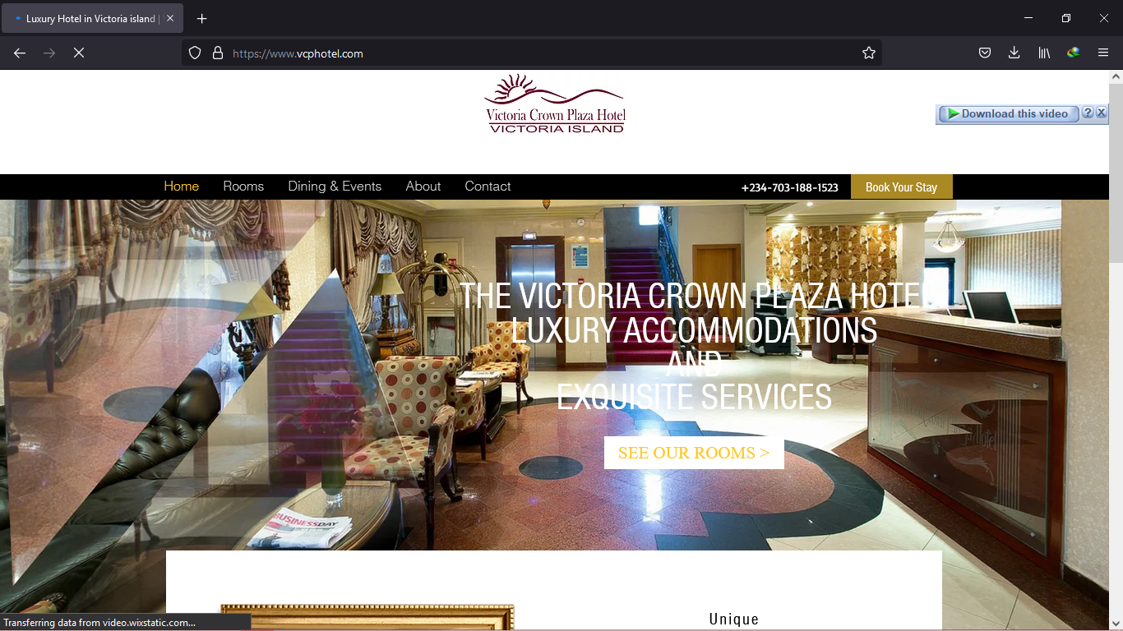

## 

## LOCAL CASE STUDY (Hilton Hotel management system)

I have compared my project with Hilton hotel management system. This is one of the best hotels located in Kenya, Nairobi. It has several departments where each uses system to run their management efficiently and smoothly.

The manager use database to record the details of each employee and area they work. This is similar as the one I proposed in the new system whereby manager can go for specific person if anything happen in certain area using the system.

They have front office operation where the computer is used to perform certain task like guest check-in, guest profile information, room allocation and check-out. I have proposed similar feature into the new system since front desk is crucial point that can impress guest arrives at the hotel.

They also have housekeeping management the same way as in my as in new proposed system, this module manage the cleanliness of property and laundry service. The system keeps the record of each and every guest who arrives at the hotel which is similar as the feature I introduce in the new system as this can make the work easier for the personnel to retrieve the details of specific on time using system.

Hilton hotel management system also have features like on line booking, I have also introduce the same feature in the new system I proposed as this gives guest freedom to make a reservation online directly through internet connectivity. Booking through the system also prevents the double booking of the room as the system shows that the room is already occupied if another person tries to book the same room.

Other feature of Hilton hotel management software is account management, this module manages revenue transaction and makes suggestion for revenue generation and also generate the bill for the guest. This functions similar way as I proposed in the new system whereby it can calculate the bill of the guest and generate out receipt for the person, calculating this manually was very difficult. Marketing management also was another feature of Hilton software and works similar way as the one I introduce in the new system. This manages different market segment and business source and help to target the market accordingly. The manager also creates database and records the perishable and non-perishable goods received from suppliers.

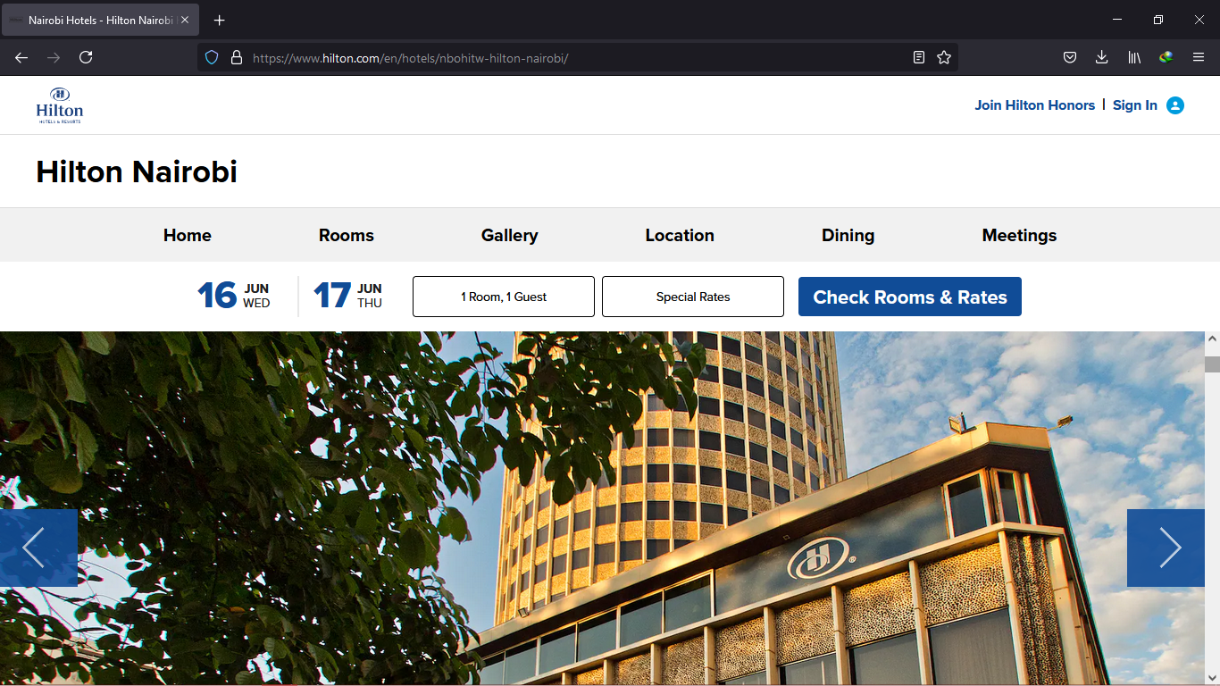

## PROPOSED SYSTEM

The new system I introduced which is TAMTAM Hotel information management system works the same way as that one of international hotel and local which I review. This is because most of the features are similar and have same functionality.

I decided to add some features in few areas like security department in the new proposed system. After I discovered that theft in the hotel and dishonesty of worker is another problem as I was told by the manager.

I also introduce database for security department as they can keep the records of the movement of fixed assets of property and also keeps the record of received material from outside and dispatched material.

The system also keeps safe the details of the guest arrived at the hotel as well as time they arrived and time they depart. This makes easy for the personnel to retrieve the details of specific person easily on time. It also keeps the record of employees in each sector and time they supposed to work. This makes the hotel management to run smoothly and efficiently for the manager as he/she just use the software to get the specific person whose duty has not been performed as required.

## CONCLUSION

I conclude that all the stated case above relate in one way or the other. This is because they all have the same features and functionality. For instance, all of them use database to process, store and retrieve their data, thus the systems are preferred compared to manual system which is time consuming, tiresome and prone to loss of data

# CHAPTER THREE

## METHODOLOGY

I intended to use waterfall model or structured system analysis and design in coming up with my system. This is because this method of system modeling enhances use of diagram to illustrate the functionality of the system

Workflow

In coming up with new system, I intended to use waterfall

Requirement analysis and problem definition

System and software design

Implementation and Testing

Integration and Testing

Operation and Maintenance

**Phase 1:** Requirement analysis and design-This is a phase where I will establish the systems goals that it has to achieve and the constraints to it and development methodology

**Phase 2**: System and software design-This is a phase where I will establish the overall architecture and requirement of either hardware or software that is going to be used in the system.

**Phase 3**: Implementation and Testing-In the phase I will put into practice what I will have establish developed and do testing to each and every segment of the system to ensure that final result will going to have no or minimal error.

**Phase 4**: Integration and system testing-At this point after performing unit testing, I will integrate the single unit into the whole system and then perform testing to the whole system in case there might be some omission during the unit testing hence it will improve the system performance.

**Phase 5**: Operation and Maintenance-Finally after I develop the system, I will put it into practice and as the system continues operating, I will fix errors and do minimal changes where needed.

## System Design

The proposed system will be designed in modules whereby each module work together to perform the operation in TAMTAM Hotel management system. This is done in order to enhance the performance of the existing system.

## Data Collection

I need to pick a few information assortment strategy to request the data about the current framework. These strategies resemble perception, meeting and poll. These strategies made my proposition truly effective.

Perception I chose to visit the lodging and see what is happening in the inn according to the board level. The meeting of the climate empowers me to perceive how is being managed my own eyes.

Meeting this is a reality discovering procedure whereby you can gather the genuine data from the worry work force like director through eye to eye collaboration. I will utilize this strategy to accumulate data from chief as this can assist me with testing for more criticism from the administrator. Finally, I decided to use questionnaire as this one also is another method of data collection. I compile several questions on existing system by repeatedly checking problems. The purpose of the questionnaire is to understand the performance of the existing system. The questionnaire allows the analyst to collect facts from large number of people while maintaining uniform response.

## Limitation of the study

Lack of available or reliable data will lead to system problem that likely required you to limit the scope of your analysis and the size of your sample. It is not possible to replace all facts and this may be a problem to researcher. Measures used to collect data are sometimes difficult as they might consume a lot of time and also inaccurate answer. For instance, In the case of observation, people usually feel uncomfortable when being watched they may unwittingly perform differently when being observed. It is also time consuming as one goes from one place to another for observation purpose.

## SYSTEM DEVELOPMENT TOOLS AND TECHNIQUES.

This involves modeling of the system using diagram. The diagram will represent the actual system on how it will be developed and how it functions once it has been developed. The purpose of the diagram is used to enable the analyst to understand the proposed system so that he/she can be able to design the actual system.

These diagrams include;

* Context Diagram
* Dataflow diagram
* Flowchart diagram
* Entity Relation diagram

## Context Diagram

This is a summary of my system. It shows the system and immediate users of the system. They are represented by showing each and every action which is undertaken in my system.

Room

Allocation

Fill the form

**TAMTAM HOTEL MANAGEMENT SYSTEM**

Guest check-in Guest payment

Guest enquiry

For service

## Data Flow Diagram

Data flow diagram is a detailed diagram about my system. It shows the process and how they occur in sequence from the beginning to the end and their logical storage

Stores

1

Check-in/Reception

Retrieve Stores details of guest

Stores

2

Booking

Retrieve Stores details of room

Categories

3

Payment

Stores

Retrieve Stores financial record

4

Service

Stores Stores enquiry

Retrieve Of guest

5

Report generation

## FLOWCHART

This is a diagram that shows the logical flow of the system from beginning to the end indicating clearly where decision is made

Service

Allot room number

Is the money paid?

Payable amount is displayed

Choose room category

Is the form filled correctly?

Fill entry form

Check-in

NO

## Entity Relation Diagram

This is a diagram that shows various entities and their attributes and how those entities interact with other entity

Guest

Booking Office

Cashier

M

1

M

1

**LIMITATION**

As a researcher I was faced with several problems while collecting data. I used several data collecting technique for fact finding.

These are like; Observation, Interview and others. For the case of observation, it is must for me to leave the desk to do research and people usually feel uncomfortable when being watched, they might intentionally perform differently when being observed

Interviewing also was very time consuming and therefore a costly fact-finding approach. Some of the officials may not easily approachable and to that extent the data may prove inadequate.

**RECOMMENDATION**

The system working will be improved within the due working of the system. The manager of TAMTAM Hotel should maintain cleanliness of the environment and rooms by mobilizing workers. The cleanliness of environment and rooms impress guest to the hotel as this increase the growth of the hotel

The manager should also add more employees who are computer literate and also train those who are computer illiterate. Many employees with computer skills make the working process of the hotel to run smoothly and efficiently as everything are computerized. The manager should also do more research on causes of theft in the hotel and how to control these problems.

Finally, the manager should conduct refreshing events and entertainment shows on regular basis to attract more customers as most of the tourists who stay in a hotel room expect refreshing events and entertainment programs for getting relaxation from the stressful condition

CONCLUSION

In conclusion, comparing the manual and the computerized system, the computerized system was more preferable because it enhance the standard and working environment as well as efficiency and reliability. It also makes work easier for the manager and personnel. I believe that the system has met the predefined requirements thus it can able to perform its functions well effectively and efficiently

# CHAPTER FOUR

## SYTEM ANALYSIS AND REQUIREMENTS MODELING

**Introduction**

System Analysis works with customers to identify goals and build systems to achieve them. System analysis is an important phase of any system development process. The system is studied to the minutest details and analyzed. The system analyst plays the role of an interrogator and dwells deep in to the working of the present system. In analysis, a detailed study of these operations performed by a system and their relationships within and outside of the system is done. A key question considered here is, “what must be done to solve the problem?” One aspect of analysis is defining the boundaries of the system and determining whether or not the candidate system should be considered. The system is viewed as a whole and the inputs to the system are identified. The outputs from the system are traced through the various processing that the input phases through in the organization. During analysis, data is collected on available files, decision points, and transaction handled by present system. Once analysis is completed the analyst has a firm understanding of what is to be done.

## Description of The Current system

Tamtam hotel management system has been handling their management by recording activities and their function manually. Tamtam Hotel and the agents are responsible in handling the above processes.

All the information about reservation details, client details, property details, booking system, payment details are recorded in a file manually. They are stored in a special place, which takes a huge space. Although they are arranged by the year, it’s difficult to find for a specific record within those files.in other words its

The disadvantages of the current manual Tamtam hotel management system can mention as follows:

• It is time consuming.

• Often the data are lost and the Agent is not aware of this.

• Lots of Manual labor is required for manual record keeping.

• Data is not always reliable as it is hand written and some human errors might have occurred.

• Difficulty of searching and retrieving records.

• Slow process of reservation.

• Low in security.

• Files are prone to theft-unauthorized modification due to low data security levels and standards.

• Retrieval of guest records is extremely difficult

## System Analysis and model

PRINCIPLES OF SYSTEM ANALYSIS

1. Understand the problem before you begin to create the analysis model.

2. Develop prototypes that enable a user to understand how human machine interaction will occur.

3. Record the origin of and the reason for every requirement.

4. Use multiple views of requirements like building data, function and behavioral

Models.

5. Work to eliminate ambiguity.

## Requirements Definition

## Functional Requirements

The system is expected to perform the following basic functions:

Data Entry, Storage and Retrieval

The Tamtam hotel database will enhance the efficient storage, retrieval and manipulation. all general information regarding an item attribute should be stored in a particular table. The system should be able to capture and save the Client’s personal details. The concerned users should have the facility to query to the database and supply the basic information easily. The database should be organized in such a way that it helps in preparing various essential summaries needed for users.

## Non-functional requirements

The system should have the following other characteristics:

* fast and efficient
* The system is not complicated and even novice computer users can use it.
* The system is user friendly, thus it is easy to navigate.
* The data in the system is saved in the database. This minimizes data loss
* The system will be able to provide security of the information stored by preventing access to the system by unauthorized and unauthenticated users.

# CHAPTER FIVE

## SYSTEM DESIGN

**5.0** Introduction

This chapter builds on the work done in the System Analysis Chapter and gives documentation for the Design of the Tamtam Hotel Management System. The system was modelled in terms of objects and classes and their interactions with each other. The interphase designs for the system were included in this chapter.

outputs, file and database design.

## Database Design

**Database: Tamtam hotel** **Management system**

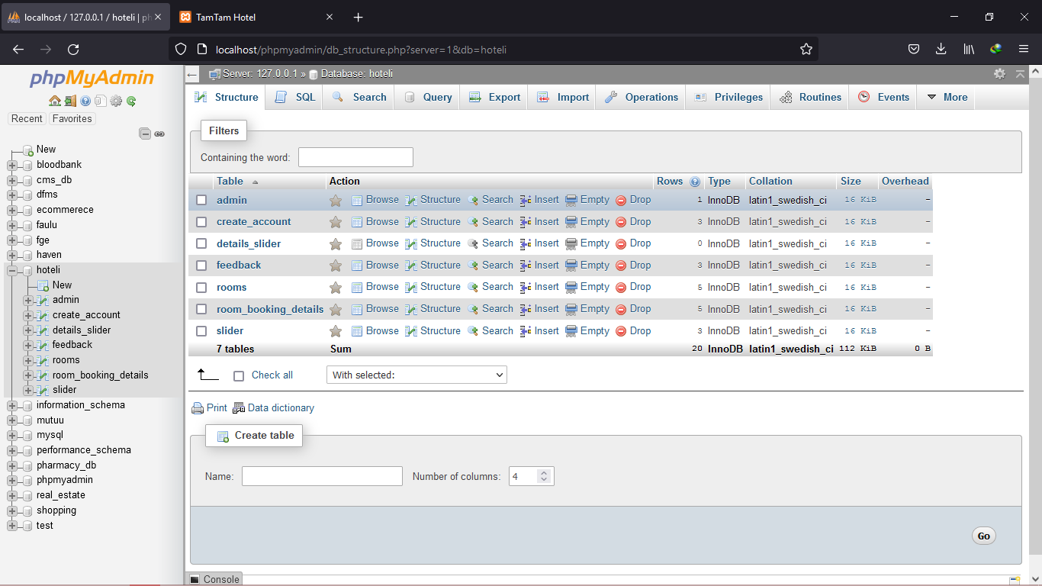

**Admin table:**

In this table , the admin username and password are set and stored.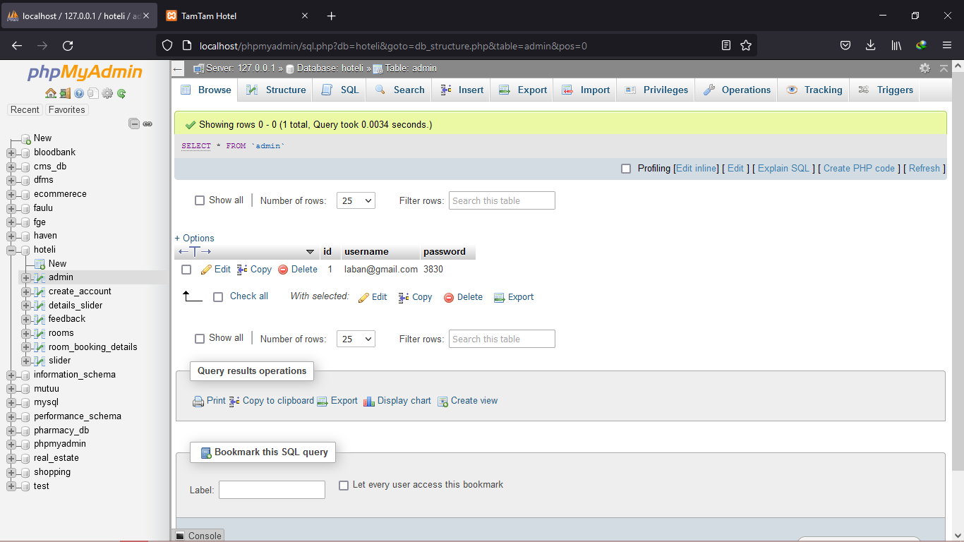

**The user table:**

Under this table, the users which create any account are stored in this table.

It has user login credentials like the username and the user email.  
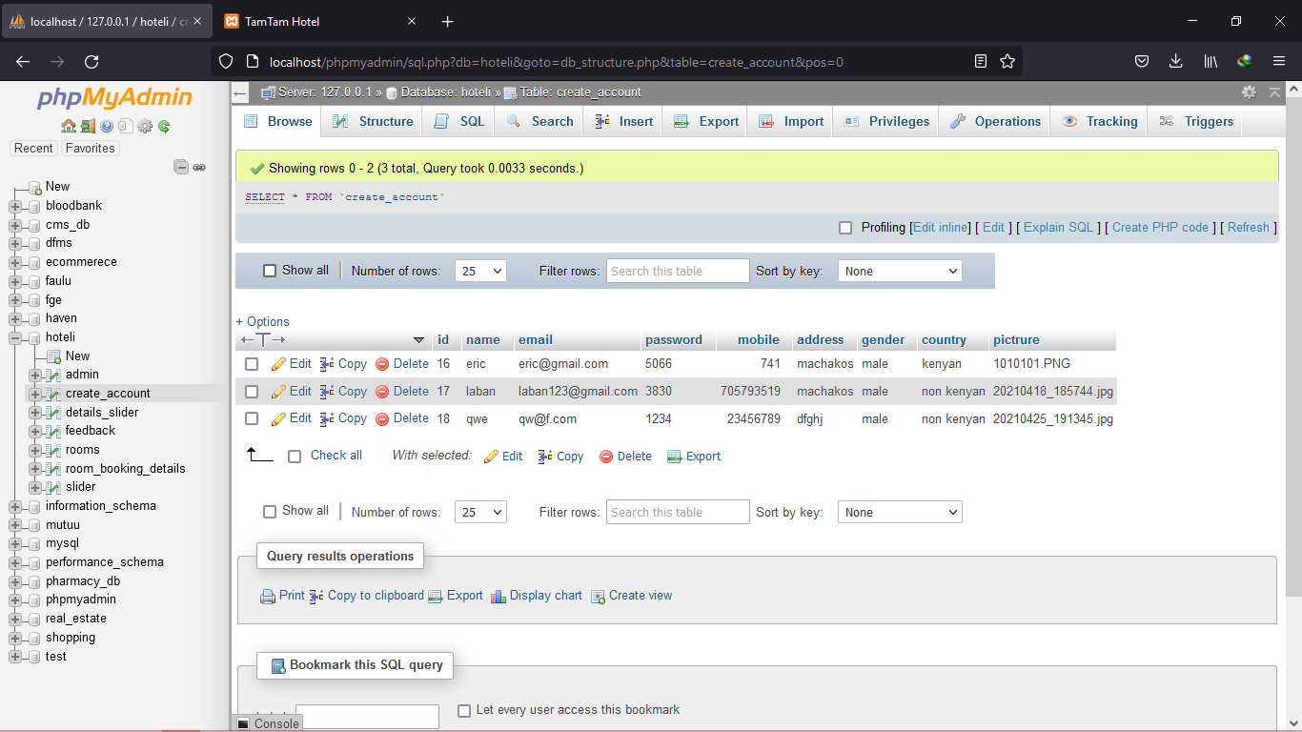

**The room table:**

Under this table the available room are stored in it.

Sif the admin adds a new room it is automatically added into the table.

If also has the room price tags for every room for query during room booking.

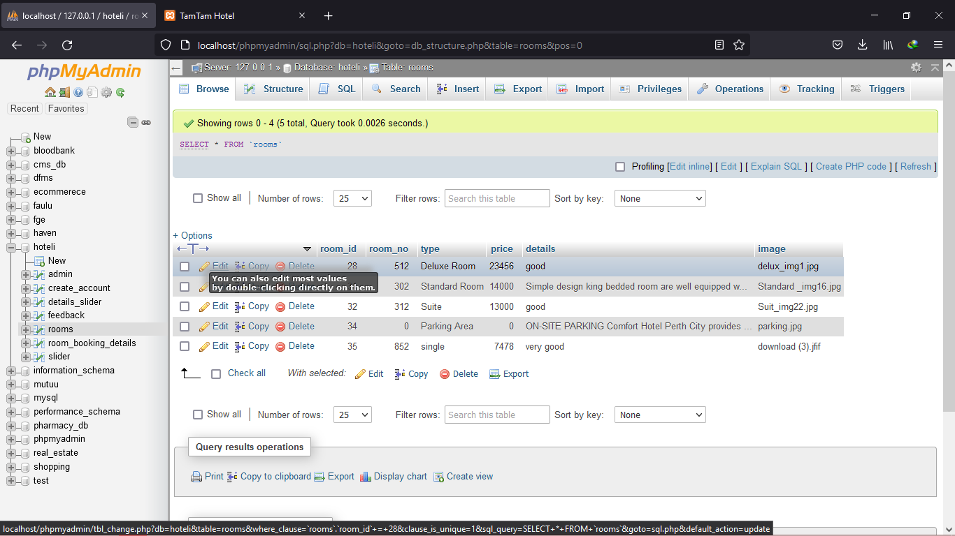

**The room booking table:**

This table has the user booking details.

With the number of room the user has booked and the amount paid for the same booking.it also has the type of room the user has booked, either the single , twin or double room with the specific amount for each booking .

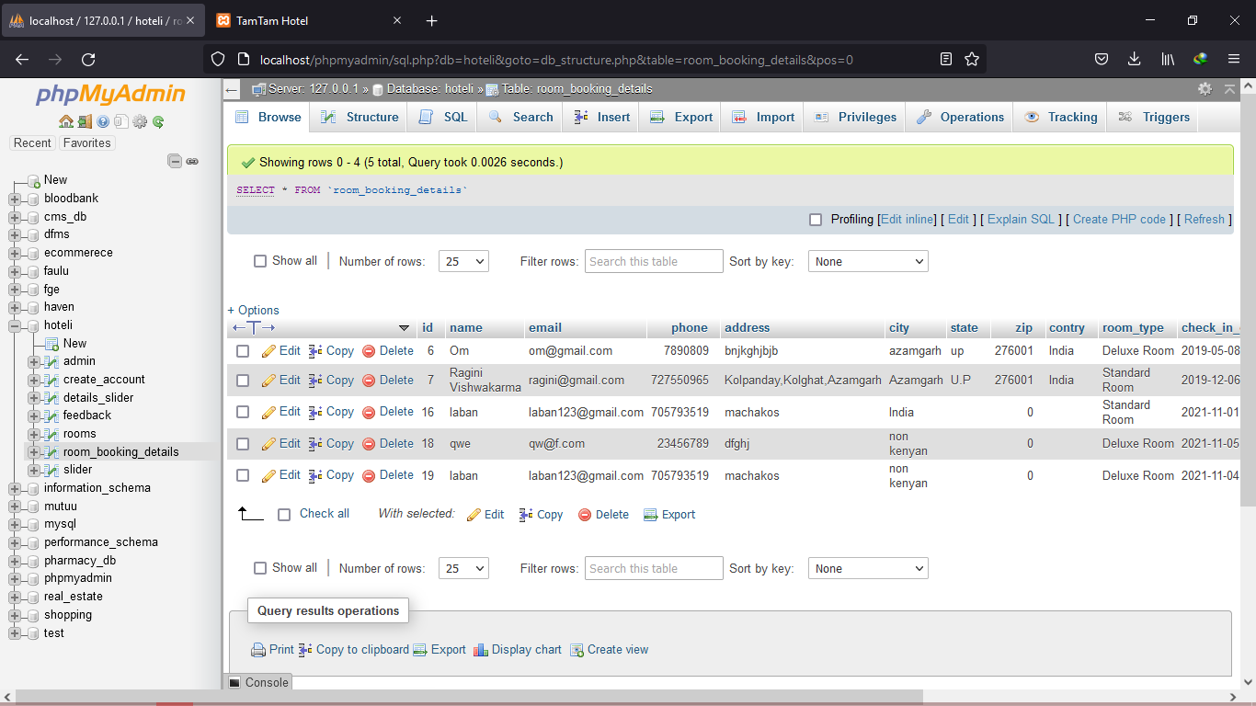

**5.3 Interface design**

The system was created with the following design considerations in mind:

**Consistent**. The system should have a similar look and feel on every page. Every page should have navigations.

**Efficient and easy to maintain**. This refers to the fact that there is need to separate content from layout, so that you can easily change your page design without editing every page on the site.

**Layout**. The layout of each page should have a good contrast between the text and background area. This helps considerably with visibility as it will be difficult to read the text if it is almost the same color as the background. Monitor size should also be taken into consideration.

**Easy to navigate and use**. Users should not have a hard time trying to navigate the site. Navigation links should be consistent and clearly labeled. All navigation links should also be working properly and should point to the intended page/site.

**Browser compatible**. When designing the site consider different browser environments. Extensive testing should be done on each page in all the major browsers and the design changed appropriately to cater for all.

**Visually appealing**. The use of color, text, fonts and graphics should be carefully considered and used to ensure that the site is visually appealing to its visitors.

## Screenshots of the system designs.

**Interface of the home page:**

The home page has the general view of the website, with the available rooms for booking and the general lookout of the TAMTAM hotel.

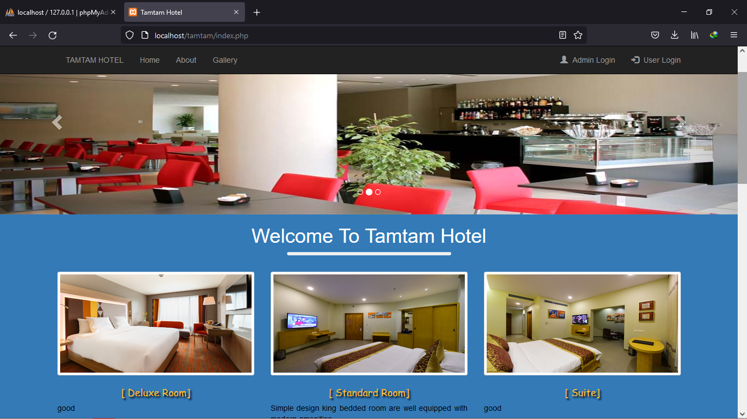

**Interface for Admin login**

The admin page has the admin login form which allows the admin to be able to login to the system and have full control

It separate the normal users to the admin and offer different privileges to the system.

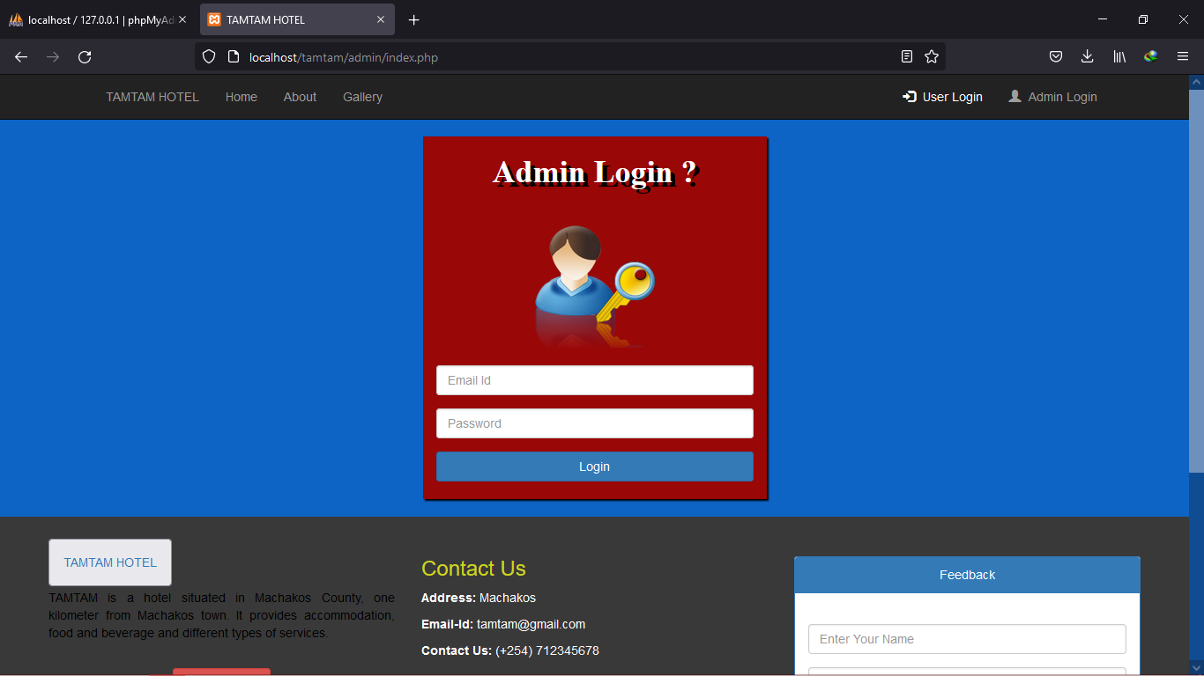

**Interface of the Administrative portal index page:**

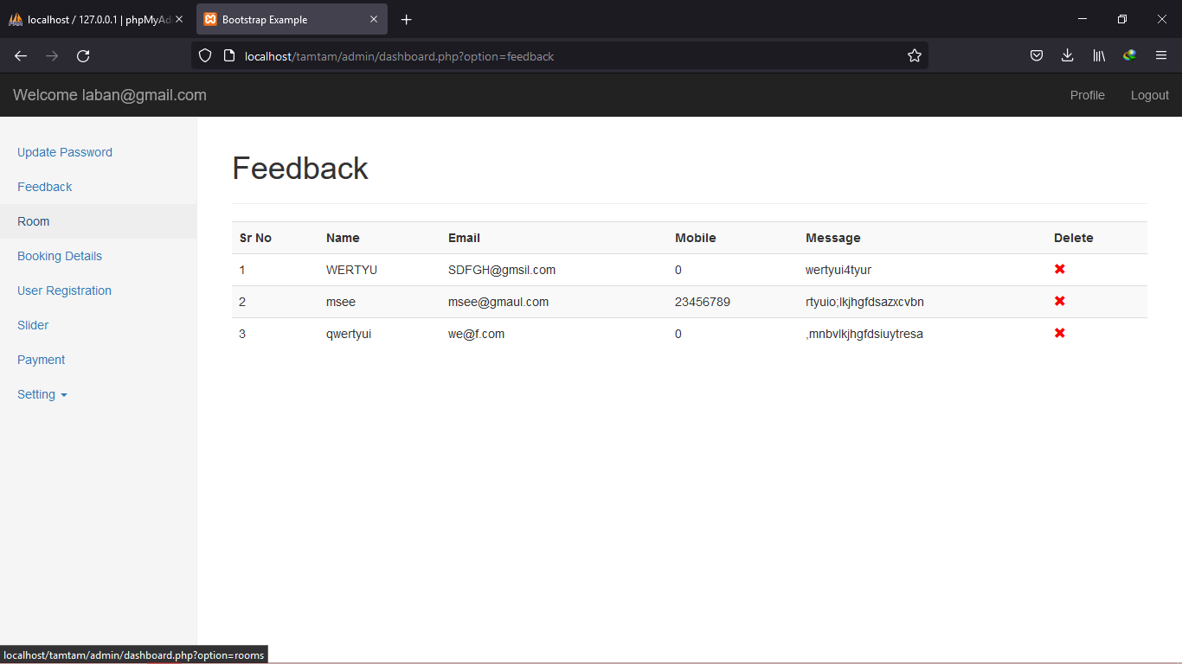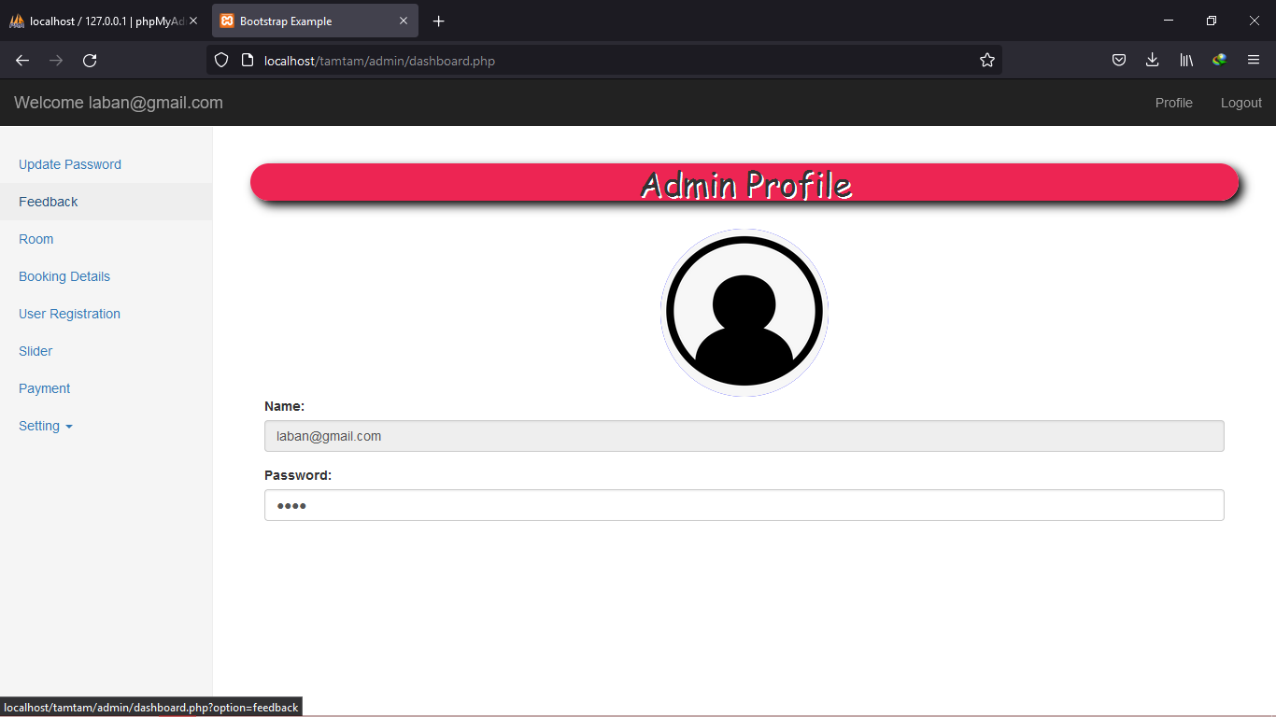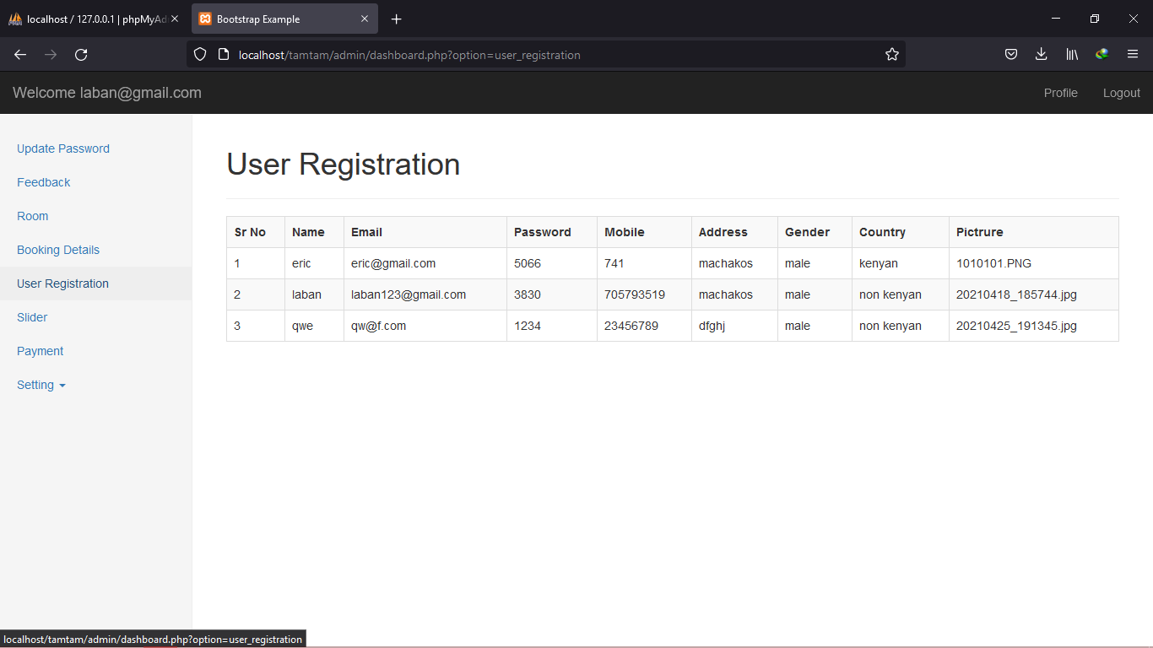

# CHAPTER SIX

## SYSTEM IMPLEMENTATION AND TESTING

## **Introduction**

This chapter explored the different aspects concerned with the implementation of the developed system. This project was concerned with the development and implementation the Tamtam Hotel management system. We began with analysis of the current and proposed systems, the design of the system to be developed, and in this chapter, we dwelt with implementation of the developed system.

## Accessing the system

Various companies and organizations may have different structures and hierarchy. Being generic, the developed System has two main access levels which are:

1. Admin/Agent
2. Clients

All users were presented with the different login interface. User must login the system by means of valid username/password combination. clients could only access the system once they registered themselves. After access was granted to the system, the clients were allowed to view the property and land for commercial and residential purposes.

## 6.2 System installation

The system was developed and tested on a laptop computer running Windows 10, and the XAMP Server. In order for the Web application to be accessible via the browser it will have to be installed on a Web Server running Apache, PHP and MySQL. The suitable operating system for the web server will be Linux as it is more stable and less prone to virus but a windows based platform will equally do the job just as well. A suitable domain name will have to be chosen and registered in order for the web application to be accessed via a URL and hosting and administration fees paid to the web hosting company of choice either annually or monthly depending on the package and terms agreed upon. The web application will be accessible via most of the popular web browsers on the market. A suitable web browser e.g. Mozilla Firefox will have to be installed on the client machine wishing to access the web application.

## 6.3 System Test plan

(Table 6)

|  |  |  |  |
| --- | --- | --- | --- |
| **Task** | **Procedure/input** | **Expected/Output** | **End result of the task** |
| **Client registration** | clients were registered by the staff | No duplicate clients in the system | Success |
| **Log in** | After registration, the clients logins to the system. | client is logged into the system after provision of correct username and password. | Success |
| **Add new property** | An agent adds new property | A new room appears in the dropdown | Success |

## 6.**4** SYSTEM TESTING

This is procedures carried out to check the working of the system. In order to get an integrated and well-coordinated system, it was desirable to test the working of the overall system. This involved testing of all the units/sections so as to ascertain that they are working as per user's expectation.

# Strategies used for testing

## Unit Testing

It focused on the verification of the smallest unit in the system design in each module. It involved testing the;

## Integration Testing

Integration testing is where the individual software modules are combined and tested as a group. Integration testing identifies problems that occur when units are combined. By using a test plan that requires you to test each unit and ensure the viability of each before combining units, you know that any errors discovered when combining units are likely related to the interface between units. This method ensures that errors are not present into the integrated components. Integration testing takes as its input [modules](http://en.wikipedia.org/wiki/Module_%28programming%29) that have been unit testing. The testing has applied a top-down strategy to validate high level components of a system before design and implementations have been completed. The development process started with high level components and we worked down the component hierarchy.

## Acceptance Testing

Acceptance testing is a test conducted to determine if the requirements of a specification are met on the proposed system. Users involves to analyze acceptability and usability and also to identify areas that will require modifications before the system can fully be commissioned for use

## System changeover

The changeover technique chosen was the parallel method. The new system would be run alongside the old manual system until correctness was achieved and all users are familiar with its operation. This was the most suitable method because all users needed to be trained on the operation of the new system. Once correctness and familiarity of the new system is established, the old system would be discontinued all together.

# CHAPTER SEVEN

## LIMITATIONS, CONCLUSIONS AND RECOMMENDATIONS

## Introduction

The aim of this chapter is to draw conclusions of the work done or achieved and to give an assessment of the completed system, discuss the Problems faced, limitations of the system and give future recommendations on how the system can be improved

## Limitations

Throughout the writing of the project the following problems were encountered:

* Time: writing of the project required a lot of time
* Data collection: this was a problem in that some of the techniques used for data collection especially those that required immediate responses were difficult to implement.
* During coding there were some codes could not run and had to spend a lot of time debugging for the system to perform as it is expected.
* The costs incurred in gathering and collecting information and travelling cost was quite high
* The problems encountered during the coding were purely due to lack of knowledge in various technical aspects. The lack of in-depth knowledge in various concepts of visual studio, and database concepts was the problems faced.
* The heavy rains also slowed time for research.

## **Achievements**

Functions that were specified in the objectives were nearly all achieved with the likes of:

* Reduction of manual operation
* Improved security of data by storing data in the database

## Reduction of time wasting by acting as the connecting bridge between the buyer and the seller

## 7.2. Recommendation

The following are the recommended for future improvement during the study:

### System Support

humans are imperfect and the system may be prone to error then it automatically follows that these systems will cause problems occasionally though minimized. It requires regular support to minimize bugs.

### System Support

Since it is a human who design these systems and humans are imperfect then it automatically follows that these systems will cause problems occasionally though minimized. It is a fact that no system can be designed that is bug free. Many cases have been reported of system crashes that lead to lose of valuable time and data

### User Training

Users need to be trained on how to use the new system to be effectively utilized, on what it can and what it cannot achieve. The recommendation is for the need to prepare user manuals, documentation of the system and the need to set up a time schedule for the training such that it does not disrupt work in the entire institution.

### Security

There is the need to include security measures in the proposed system such that only those authorized to carry out entries are authorized to do so. This will be done through the use of password facility when the system executes.

### Security

The other recommendation is to integrated the system will the android application to make it a hybrid system.

## Conclusion

The system accomplished the objectives it was created for since it reduced the time taken when serving the clients since the system was already automated. The clients were now being served faster which there was a general increase in the productivity . They were able to book for property and being connected to sellers of the property and land.

The integrity and confidentiality of the client’s data was enhanced. Each individual client had a unique username, password and they could log to their individual accounts and see their booking statement. This enhanced the security since unauthorized users could not manipulate the client’s data.

Data duplication was eliminated completely since the developed system could identify duplicate client’s records and output a message for the staff. This reduced the data redundancy in the system.

In conclusion, the project study has provided me with the opportunity improve and learn more on my development and design skills. Also has enhance me with research, planning, and time management skills and development organization of the system.

## REFERENCE

Cross, R. G., Higbie, J. A., & Cross, D. Q. (2009). Revenue management's renaissance: A rebirth of the art and science of profitable revenue generation. *Cornell Hospitality Quarterly*, *50*(1), 56-81.

Vallen, G. K., & Vallen, J. J. (2009). *Check-in check-out: Managing hotel operations*. Upper Saddle River, NJ: Prentice Hall.

Mok, H. F. (2003). *Hotel Management Information System/Mok Hei Fung* (Doctoral dissertation, University of Malaya).

Antonakakis, M., Perdisci, R., Dagon, D., Lee, W., & Feamster, N. (2010, August). Building a dynamic reputation system for dns. In *USENIX security symposium* (pp. 273-290).

## Some code for the system.

**Index.php**

<?php

session_start();

error_reporting(1);

include('connection.php');

?>

<!DOCTYPE html>

<html lang="en">

<head><!--Head Open  Here-->

  <title>Tamtam Hotel</title>

  <meta charset="utf-8">

  <meta name="viewport" content="width=device-width, initial-scale=1">

  <link rel="stylesheet" href="https://maxcdn.bootstrapcdn.com/bootstrap/3.4.0/css/bootstrap.min.css">

  <script src="https://ajax.googleapis.com/ajax/libs/jquery/3.3.1/jquery.min.js"></script>

  <script src="https://maxcdn.bootstrapcdn.com/bootstrap/3.4.0/js/bootstrap.min.js"></script>

  <link href="https://fonts.googleapis.com/css?family=Abril+Fatface" rel="stylesheet">

  <link href="css/style.css"rel="stylesheet"/>

</head> <!--Head Open  Here-->

<body style="margin-top:50px;">

  <?php

      include('Menu Bar.php')

  ?>

<div id="myCarousel" class="carousel slide" data-ride="carousel"> <!--Slider Image Start Here-->

    <!-- Indicators -->

    <ol class="carousel-indicators">

      <li data-target="#myCarousel" data-slide-to="0" class="active"></li>

      <li data-target="#myCarousel" data-slide-to="1"></li>

     <li data-target="#myCarousel" data-slide-to="2"></li>

    </ol>

    <!--Indicators Close Here-->

    <!-- Wrapper for slides -->

    <div class="carousel-inner" role="listbox">

      <?php

    $i=1;

    $sql=mysqli_query($con,"select * from slider");

    while($slider=mysqli_fetch_assoc($sql))

    {

    $slider_img=$slider['image'];

    $slider_cap=$slider['caption'];

    $path="image/Slider/$slider_img";

      if($i==1)

      {

    ?>

    <div class="item active">

        <img src="<?php echo $path; ?>" alt="Image">

        <div class="carousel-caption">

      <h2><?php echo $slider_cap; ?></h2>

    </div>

      </div>

    <?php

    }

    else

      {

      ?>

    <div class="item">

        <img src="<?php echo $path; ?>" alt="Image">

        <div class="carousel-caption">

        <h2><?php echo $slider_cap; ?></h2>

    </div>

      </div>

    <?php } ?>

    <?php $i++; } ?>

    </div>

    <a class="left carousel-control" href="#myCarousel" role="button" data-slide="prev">

      <span class="glyphicon glyphicon-chevron-left" aria-hidden="true"></span>

      <span class="sr-only">Previous</span>

    </a>

    <a class="right carousel-control" href="#myCarousel" role="button" data-slide="next">

      <span class="glyphicon glyphicon-chevron-right" aria-hidden="true"></span>

      <span class="sr-only">Next</span>

    </a>

    <!-- Left and right controls Close Here -->

</div> <!--Room Info Start Here-->

 <div class="container-fluid"id="red"><!--Id Is Red-->

<div class="container text-center">

  <h1>Welcome To Tamtam Hotel</b></h1><hr><br>

  <div class="row">

    <div class="hov"><!--Hov is Class-->

  <?php

  $sql=mysqli_query($con,"select * from rooms");

  while($r_res=mysqli_fetch_assoc($sql))

  {

  ?>

  <div class="col-sm-4">

      <img src="image/rooms/<?php echo $r_res['image']; ?>"class="img-responsive thumbnail"alt="Image"id="img1"> <!--Id Is Img-->

      <h4 class="Room_Text">[ <?php echo $r_res['type']; ?>]</h4>

      <p class="text-justify"><?php echo substr($r_res['details'],0,100); ?></p><br>

      <a href="room_details.php?room_id=<?php echo $r_res['room_id']; ?>" class="btn btn-danger text-center">Read more</a><br><br>

    </div>

  <?php } ?>

  </div>

  </div>

</div>

</div>

<?php

  include('Footer.php')

?>

</body>

</html>

**BOOKING FORM:**

<?php

include('Menu Bar.php');

include('connection.php');

if($eid=="")

{

header('location:Login.php');

}

$sql= mysqli_query($con,"select * from create_account where email='$eid' ");

$result=mysqli_fetch_assoc($sql);

//print_r($result);

extract($_REQUEST);

error_reporting(1);

if(isset($savedata))

{

  $sql= mysqli_query($con,"select * from room_booking_details where email='$email' and room_type='$room_type' ");

  if(mysqli_num_rows($sql))

  {

  $msg= "<h1 style='color:red'>You have already booked this room</h1>";

  }

  else

  {

   $sql="insert into room_booking_details(name,email,phone,address,city,state,zip,contry,room_type,Occupancy,check_in_date,check_in_time,check_out_date)

  values('$name','$email','$phone','$address','$city','$state','$zip','$country',

  '$room_type','$Occupancy','$cdate','$ctime','$codate')";

   if(mysqli_query($con,$sql))

   {

   $msg= "<h1 style='color:blue'>You have Successfully booked this room</h1><h2><a href='order.php'>View </a></h2>";

   }

  }

}

?>

<!DOCTYPE html>

<html lang="en">

<head>

  <title>TAMTAM Hotel.com</title>

  <meta charset="utf-8">

  <meta name="viewport" content="width=device-width, initial-scale=1">

  <link rel="stylesheet" href="https://maxcdn.bootstrapcdn.com/bootstrap/3.4.0/css/bootstrap.min.css">

  <script src="https://ajax.googleapis.com/ajax/libs/jquery/3.3.1/jquery.min.js"></script>

  <script src="https://maxcdn.bootstrapcdn.com/bootstrap/3.4.0/js/bootstrap.min.js"></script>

  <link href="css/style.css"rel="stylesheet"/>

 <link href="https://fonts.googleapis.com/css?family=Lobster" rel="stylesheet">

  <link rel="stylesheet" href="https://cdnjs.cloudflare.com/ajax/libs/font-awesome/4.7.0/css/font-awesome.min.css">

</head>

<body style="margin-top:50px;">

  <?php

  include('Menu Bar.php');

  ?>

<div class="container-fluid text-center"id="primary"><!--Primary Id-->

  <h1>[ BOOKING Form ]</h1><br>

  <div class="container">

    <div class="row">

      <?php echo @$msg; ?>

      <!--Form Containe Start Here-->

     <form class="form-horizontal" method="post">

       <div class="col-sm-6">

         <div class="form-group">

           <div class="row">

              <div class="control-label col-sm-4"><h4> Name :</h4></div>

                <div class="col-sm-8">

                 <input type="text" value="<?php echo $result[ 'name']; ?>" readonly="readonly" class="form-control" name="name" placeholder="Enter Your Frist Name"required>

          </div>

</div>

      </div>

        <div class="form-group">

          <div class="row">

           <div class="control-label col-sm-4"><h4>Email :</h4></div>

          <div class="col-sm-8">

              <input type="email" value="<?php echo $result['email']; ?>" readonly="readonly" class="form-control" name="email"  placeholder="Enter Your Email-Id"required/>

          </div>

        </div>

        </div>

        <div class="form-group">

          <div class="row">

           <div class="control-label col-sm-4"><h4>Mobile :</h4></div>

          <div class="col-sm-8">

              <input type="number" value="<?php echo $result['mobile']; ?>" readonly="readonly" class="form-control" name="phone" placeholder="Type Your Phone Number"required>

          </div>

        </div>

        </div>

        <div class="form-group">

          <div class="row">

           <div class="control-label col-sm-4"><h4>Address :</h4></div>

          <div class="col-sm-8">

              <textarea name="address" class="form-control" readonly="readonly"placeholder="Enter Your Address"><?php echo $result['address'];  ?></textarea>

          </div>

        </div>

        </div>

         <div class="form-group">

          <div class="row">

           <div class="control-label col-sm-4"><h4>Country</h4></div>

          <div class="col-sm-8">

              <input type="text" class="form-control" readonly="readonly"  value="<?php echo $result['country']; ?>" name="city" placeholder="Enter Your City Name"required>

          </div>

        </div>

        </div>

        <div class="form-group">

          <div class="row">

           <div class="control-label col-sm-4"><h4></h4></div>

          <div class="col-sm-8">

              <input type="hidden" name="state" class="form-control"placeholder="Enter Your State Name"required>

          </div>

        </div>

        </div>

          <div class="form-group">

            <div class="row">

           <div class="control-label col-sm-4"><h4></h4></div>

          <div class="col-sm-8">

              <input type="hidden" name="zip" class="form-control" placeholder="Enter Your Zip Code"required>

          </div>

        </div>

        </div>

        </div>

           <div class="col-sm-6">

            <div class="form-group">

              <div class="row">

                <div class="control-label col-sm-5"><h4>Room Type:</h4></div>

                  <div class="col-sm-7">

                <select class="form-control" name="room_type"required>

                  <option>Deluxe Room</option>

                  <option>Luxurious Suite</option>

                  <option>Standard Room</option>

                  <option>Suite Room</option>

                  <option>Twin Deluxe Room</option>

               </select>

              </div>

              </div>

            </div>

          </div>

          <div class="col-sm-6">

            <div class="form-group">

              <div class="row">

                <div class="control-label col-sm-5"><h4>check In Date :</h4></div>

                  <div class="col-sm-7">

                  <input type="date" name="cdate" class="form-control"required>

                  </div>

              </div>

            </div>

          </div>

          <div class="col-sm-6">

            <div class="form-group">

              <div class="row">

                <!-- <div class="control-label col-sm-5"><h4>Check In Time:</h4></div>

                   <div class="col-sm-7">

                    <input type="time" name="ctime" class="form-control"required>

                  </div> -->

              </div>

            </div>

          </div>

           <div class="col-sm-6">

            <div class="form-group">

              <div class="row">

                <div class="control-label col-sm-5"><h4>Check Out Date :</h4></div>

                <div class="col-sm-7">

                  <input type="date" name="codate" class="form-control"required>

                </div>

              </div>

            </div>

          </div>

          <div class="col-sm-6">

            <div class="form-group">

              <div class="row">

                <label class="control-label col-sm-5"><h4 id="top">Occupancy :</h4></label>

                <div class="col-sm-7">

                  <div class="radio-inline"><input type="radio" value="single" name="Occupancy"required >Single</div>

                  <div class="radio-inline"><input type="radio" value="twin" name="Occupancy" required>Twin</div>

                  <div class="radio-inline"><input type="radio" value="dubble" name="Occupancy" required>Dubble</div>

                </div>

              </div>

            </div>

            <input type="submit"value="submit" name="savedata" class="btn btn-danger"required/>

          </div>

          </form><br>

        </div>

      </div>

    </div>

  </div>

<?php

include('Footer.php')

?>

</body>

</html>